Experience
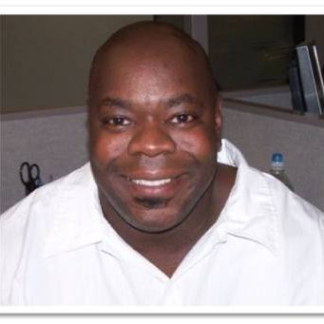

MAtt Wilson
  - On Air personality/Producer

Objective
Radio/TV On-Air or production position

Skills & Abilities and Leadership
On-Air Radio Personality/Station Programmer with 4 years of experience encompassing digital production,imaging, studio and live broadcasts, and commercial voice-overs. Expert in consistently entertaining large audiences with tireless enthusiasm. More than 15 years of experience in management in customer service in a call center environment.
• Knowledgeable in operations of state-of-the-art production studios.
• Talent for generating creative ideas and organizing projects.
• Wrote promotion copy for station events.
• Highly organized. Strong in planning and implementing programs.
• Sociable, personable, and communicate easily with a broad range of personalities

Vitals
T 585-490-6806
E radiomattwilson@gmail.com
Visit mattwilson2.weebly.com for aircheck

iheart media, Rochester, NY

2019-Present
Producer and Board Operator for talk radio and sports broadcasts

89.1 WBSU The Point, Brockport, NY

2018-Present
On air personality and responsible for production, imaging, voice tracking, and voice recordings.

100.9 WXIR, Rochester, NY

2017-Present
Creator, Producer and on air personality Friday nights from 5-7PM for Hip Hop and R&B show

Townsquare Media, Buffalo, NY

2017
Intern responsible for production, imaging, and voice recordings.

Examiner.com, San Francisco CA

2009-2014
Writer and contributor for the local bar scene and entertainment in and around Rochester, NY

Education

Brockport State University

2018-2019
Bachelors in Journalism and Broadcasting

Genesee Community College Batavia NY

2015-2017
Associates Degree in Communications

REFERENCES
WARREN KOZIRESKI, ASSOCIATE PROFESSOR AT THE COLLEGE AT BROCKPORT, GENERAL MANAGER OF WBSU 89.1 THE POINT

Contact Information for wARREN KOZIRESKI
Email: wkozires@brockport.edu
Work Phone: 585-395-2500

Val Bello, Associate Professor of Communication and Media Arts at Genesee Community College, DJ on 106.5 WYRK BUFFalo

Contact Information for Val Bello
Email: vcbello@genesee.edu
Work Phone: 585-343-0055 ext. 6286

